Entrant’s Details
Modern Apprentice Name |  |  |  | Start Date  End Date  Date of MA Certificate
Job Title

Modern Apprenticeship Framework Followed

Company Name and Address | Type of Business  (Please describe your business activity) |  |  |  | Company Contact  Tel No  E-mail address
Number of Employees in your Company |  | 0-49 50-249 250-499 500+  ☐ ☐ ☐ ☐
Entry (to be completed by Apprentice)
Introduction (80 words) (In your own words, your entry should have a brief introductory paragraph outlining the nature of your employer's
organisation and your role as a Modern Apprentice within the organisation.)
Apprentice application (to be completed by Apprentice)
Outline of Submission (300 words) (In your own words, use this section to cover the areas set out in the Judging Criteria: Capability, Commitment, Community engagement, Overcoming difficulties and Quality of submission. Use this word capacity to its maximum, use bullet points and quotes to fully maximise your impact and highlight key points / statistics in colour or bold to emphasise them.)

Apprentice application (cont.)
Employer’s Comments (200 words) (to be completed by Employer)
Declaration
I wish to enter the Trades House of Glasgow Modern Apprentice Awards. By signing the application form I agree to take part in publicity concerning the event and confirm that the details given in this application are accurate.

The Trades House of Glasgow will only use your data for correspondence relating to your entry for the Trades House of Glasgow Modern Apprentice Awards. Your personal details will not be released to third parties for purposes other than declared above. Should you not wish to receive any further correspondence from the Trades House of Glasgow relating to Modern Apprenticeship initiatives please tick here. ☐
Modern Apprentice Signature |  |  | Date
Company Contact Signature |  |  | Date
Submit completed application to jackie.mullen@tradeshouse.org.uk by deadline – Friday, 6th May 2022

The Trades House of Glasgow
APPRENTICE OF THE YEAR AWARD 2022
Eligibility
The Trades House of Glasgow Modern Apprentice of the Year Award is open to those who have completed one full year of their Scottish Modern Apprenticeship or who have been certificated no earlier than 1st May 2020, employed by any employer in Glasgow and the West of Scotland area (see map below – Local Authority areas 16-Glasgow City, 11-East Renfrewshire, 25-Renfrewshire, 31-West Dunbartonshire, 9-East Dunbartonshire, 22-North Lanarkshire, 29-South Lanarkshire, 8-East Ayrshire, 28-South Ayrshire, 21-North Ayrshire, 18-Inverclyde, 4-Argyll & Bute only).
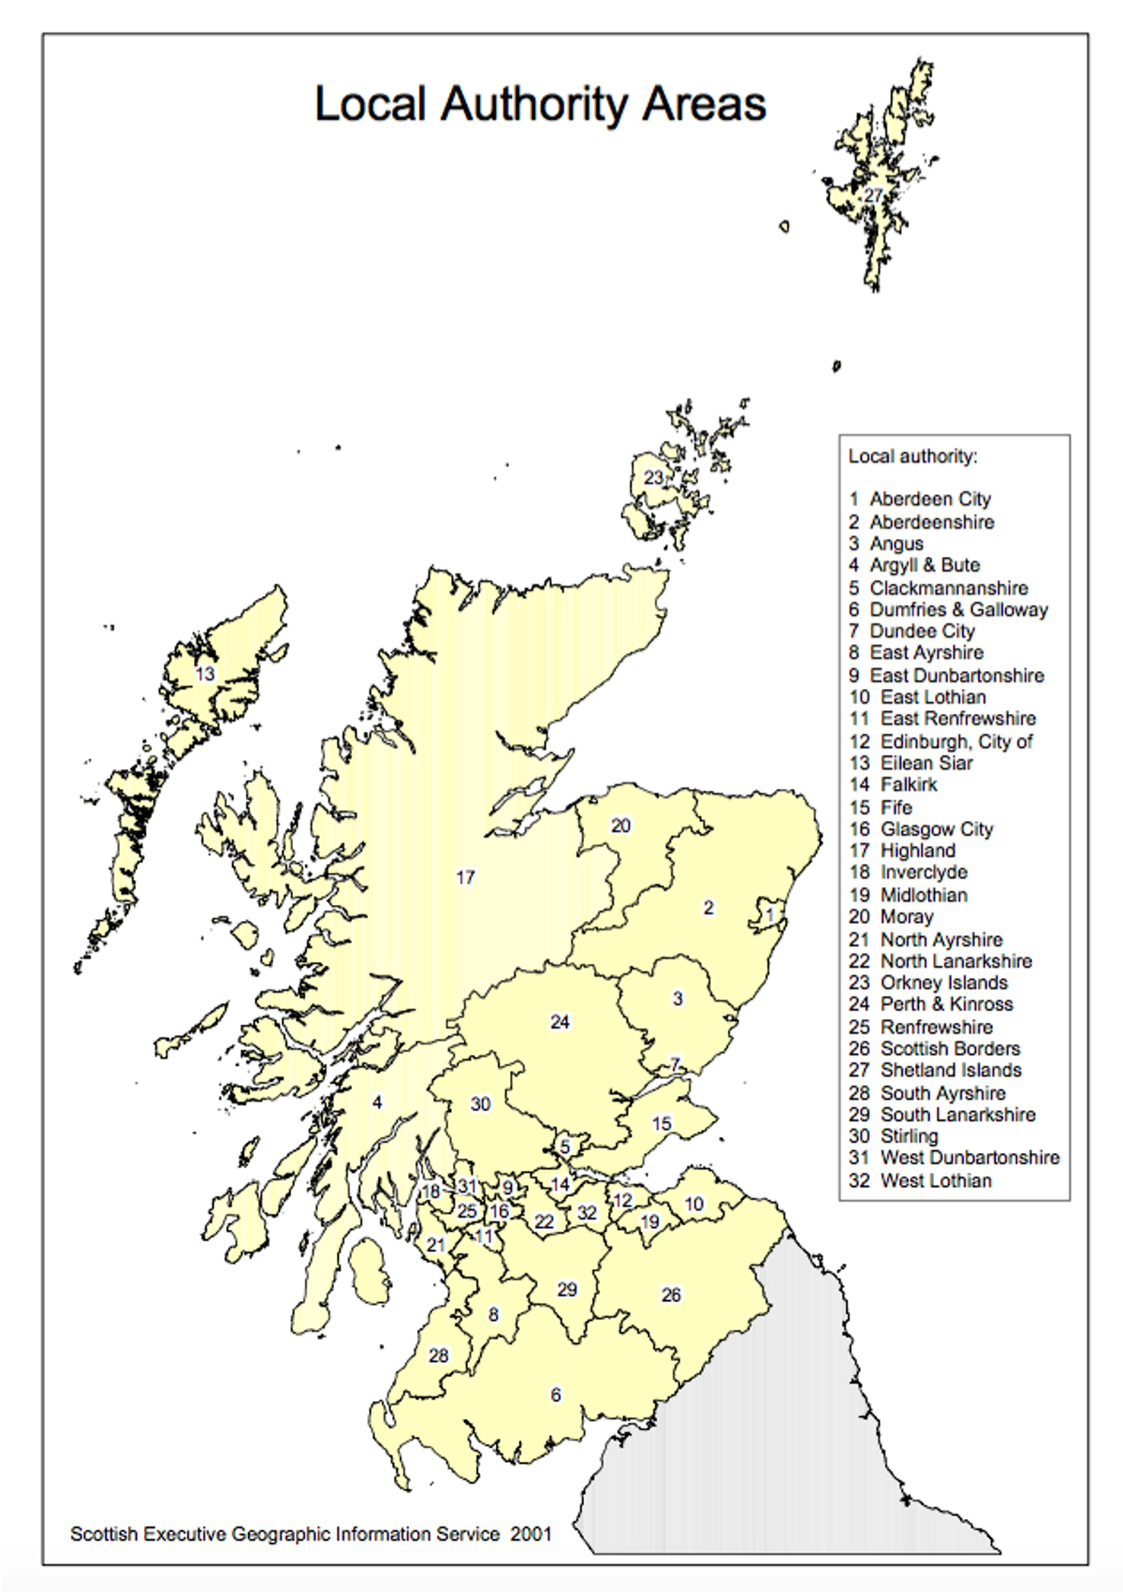
Judging Criteria
The Award will showcase the dedication, commitment and capabilities of candidates who have chosen the Modern Apprenticeship route to further their career prospects. The judging panel will choose an overall winner who they feel has illustrated the overall ideals of the Modern Apprenticeship Programme.

Entries will be judged on the criteria below. These are issued for general guidance.

Capability – 30%
Extra skills/abilities or performance one candidate may express more than others

Commitment – 30%
Personal development, before, during and after the apprenticeship

Community engagement – 20%
Potential to act as role model for other employees and the wider community

Overcoming difficulties – 10%
Range and nature of obstacles that have been overcome

Quality of submission - 10%
Overall quality and efficiency of application

For full details, terms and conditions and to enter visit www.tradeshouse.org.uk/gmaawards

The Trades House of Glasgow Modern Apprentice Awards – Terms and Conditions

No entry fee will be charged. The closing date for receipt of completed applications is 5pm on Friday 6th May 2022.

All entries must be collated and returned by one coordinating person at the organisation to whom any further enquiries will be directed.

Only material relevant to the application and submitted on the application form and any additional sheets will be considered by the judging panel.

Entries may be submitted in hard copy or by email. If submitted in hard copy, two sets (photocopies or scanned copies accepted) of each submission must be included.

The Trades House of Glasgow cannot accept any responsibility for loss or damage of any entry. No receipts will be issued and copies of submissions will not be returned.

The judges’ decision will be final and no correspondence or discussions will be entered into regarding the selection of winners.

Finalists will be selected by the Judging Panel. The Judging Panel will then contact the finalists for the purposes of validation. This may result in a site visit and video interview to be conducted in May 2022.

Finalists and their guests will be invited to the Trades House of Glasgow Modern Apprentice of the Year Award Ceremony to be held in the Trades Hall of Glasgow, 85 Glassford Street, Glasgow on the evening of 21st June at 6.00pm and will last approximately 1 hour. You can invite up to 5 guests.

The Award

3rd Prize: A cash prize of £250 for relevant further study and a certificate.

2nd Prize: A cash prize of £500 for relevant further study and a certificate.

1st Prize: The winner will be presented with a magnificent inscribed cup which will remain on display in the Trades Hall, an inscribed replica, a cash prize of £1000 for relevant further study and a certificate.

All finalists will each receive a certificate of commendation.

